Circuit Explanation
The complete project circuit can be divided into the following modules:
- Power Supply Module
- 8051 Minimal Configuration Module
- LCD Module
- ADC and LM35 Module
- LEDs Module
- Relays and Tapped Resistor Module

- Power Supply Module
The power supply module is used for converting 230V AC mains voltage into 12V and 5V DC voltages. The AC mains supply is applied to a 12V step down transformer. The transformer output is 12V AC which is rectified using a bridge rectifier. The output of bridge rectifier is DC 12V which is filtered by a capacitor, and then regulated using 7812 voltage regulator. The output of 7812 is +12V DC which is the required voltage for relay operation. The output of 7812 regulator is further filtered by a capacitor, and then regulated using 7805 voltage regulator. The output of 7805 is +5V DC which is the required voltage for microcontroller operation. Also an LED in series with 470 Ohms resistor is used for power on indication.
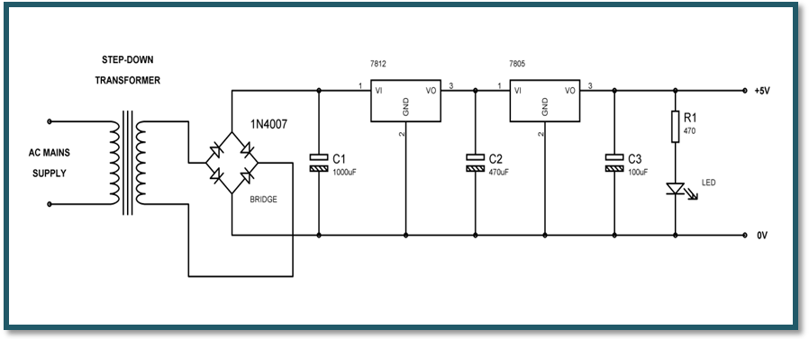

- 8051 Minimal Configuration Module
In order to use 8051 microcontroller we need the basic connections like RESET (Pin 9), Crystal (Pins 18 and 19), GND (Pin 20), EA (Pin 31), and VCC (Pin 40) as shown in the following diagram:

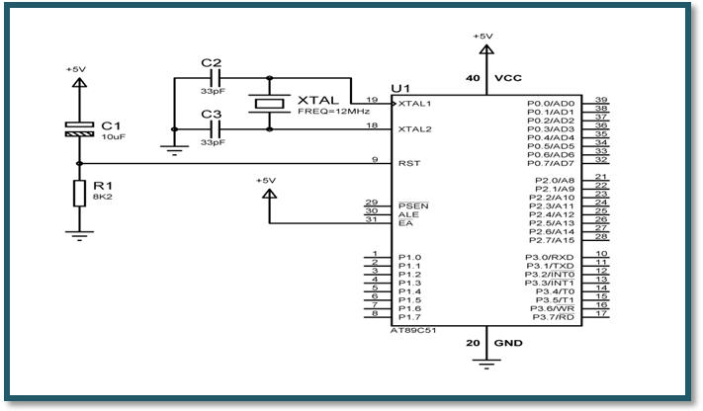
The PIN 9 is the reset pin which is used reset the microcontroller’s internal registers and ports upon starting up. A high on this pin for two machine cycles while the oscillator is running resets the device.
The PINS 18 and 19 are the crystal pins. The 8051 has a built-in oscillator amplifier hence we need to only connect a crystal at these pins to provide clock pulses to the circuit.
The PINS 20 and 40 are GND and VCC respectively. The 8051 chip needs +5V 500mA to function properly.
The PIN 31 is the external access pin. If EA = 1, the microcontroller executes the program code from its internal program memory. If EA = 0, the microcontroller executes the program code from external program memory. In our project, the program code is present in the internal program memory of 8051. So, this pin is connected to VCC.
- LCD Module

The project uses a 16x2 alphanumeric LCD to display various messages like current temperature and fan status (including speed levels). The alphanumeric LCD contains totally 16 pins and these are connected as follows:
- Pins 1 (VSS) and 16 (LED-) are connected to GND.
- Pins 2 (VDD) and 15 (LED+) are connected to VCC.
- Pin 3 (VEE) is connected to 10k POT.
- Pin 4 (RS) is connected to microcontroller (P3.3)
- Pin 5 (R/W) is connected to GND.
- Pin 6 (E) is connected to microcontroller (P3.4)
- Pins 7 to 14 (DB0 – DB7 i.e., data pins) are connected to microcontroller (Port P0).
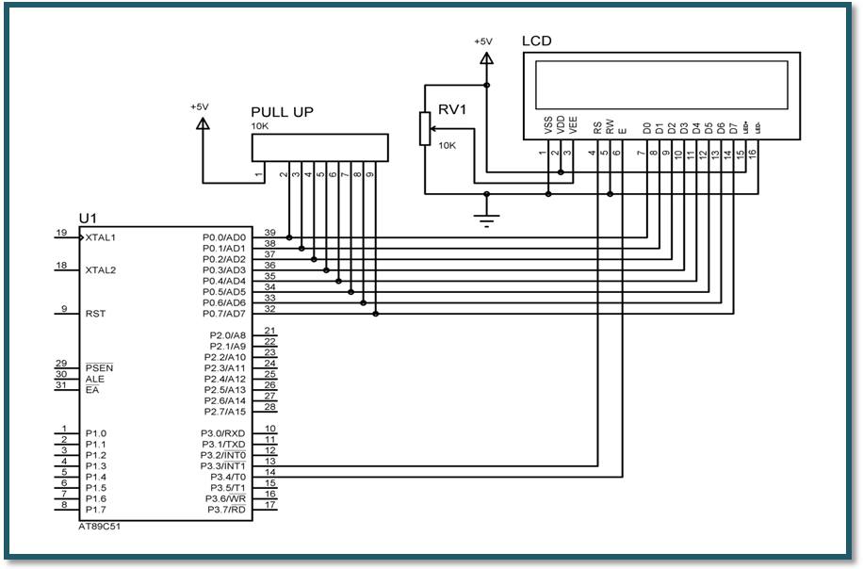
The R/W pin of LCD is connected to GND, which indicates that we are only writing to LCD. We are not reading anything from the LCD.
The data pins of LCD are connected to port P0. The port P0 doesn’t have internal pull up resistors. So, we are connecting external pull up resistors to port P0. For this, we are using a 10K resistor pack available in SIL package.
- ADC and LM35 Module
The temperature sensor LM35 gives the output in analog form. So, we are converting this analog value to digital value with the help of analog-to-digital converter. The ADC IC used in this project is ADC0804. It is available in 20-pin DIP package and we did the configuration as follows:
- Pin 1 (CS) is connected to GND.
- Pin 2 (RD) is connected to microcontroller (P3.0).
- Pin 3 (WR) is connected to microcontroller (P3.1).
- Pins 4 (CLK IN) and 19 (CLK R) are connected to a capacitor (150pF) and a resistor (10k).
- Pin 5 (INTR) is connected to microcontroller (P3.2).
- Pin 6 (Vin(+)) is connected to the output pin of LM35.
- Pin 7 (Vin(-)) is connected to GND.
- Pin 8 (AGND) is connected to GND.
- Pin 9 (Vref/2) is connected to 10k POT.
- Pin 10 (DGND) is connected to GND.
- Pins 18 to 11 (DB0 – DB7 i.e., data pins) are connected to microcontroller (Port P1).
- Pin 20 (VCC) is connected to VCC.
The temperature sensor LM35 has 3 pins and we did its configuration as follows:
- Pin 1 (+Vs) is connected to VCC (+5V).
- Pin 2 (Vout) is connected to Vin(+) of ADC0804.
- Pin 3 (GND) is connected to GND.
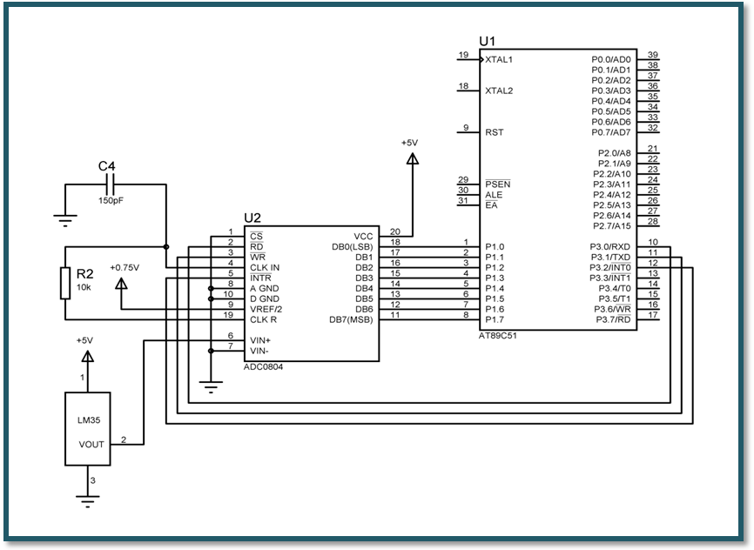
The ADC0804 has an internal clock generator. To use the internal clock generator of the ADC0804, the CLK IN and CLK R pins are connected to a capacitor and a resistor.
The output of LM35 linearly varies with temperature. The output range of LM35 is 0 to 1.50V and scaling is “10 mV per degree centigrade”. So, we need to set the reference voltage of ADC to 1.50V. For this, we are using a 10k POT and Vref/2 is set to 0.75V.
- LEDs Module
The project uses five LEDs to display the fan speed levels. If the temperature is less than 35ºC, all LEDs are turned OFF. If the temperature is greater than or equal to 35ºC and less than 40ºC, the first LED will be turned ON to indicate the speed level as 1. If the temperature is greater than or equal to 40ºC and less than 45ºC, the first two LEDS will be turned ON to indicate the speed level as 2, and so on. The following figure shows how to interface the LEDs to microcontroller. As you can see the Anode is connected through a resistor to Vcc and the Cathode is connected to the Microcontroller pin. So when the Port Pin is HIGH the LED is OFF and when the Port Pin is LOW the LED is turned ON.
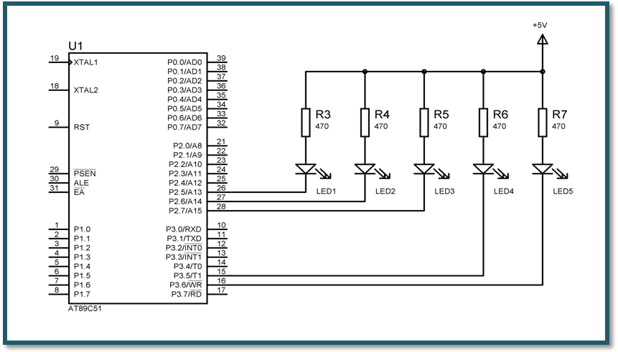
- Relays and Tapped Resistor Module
The project uses five relays a tapped wire wound resistor. We are using a tapped resistor available in normal ceiling fan regulators. With the help of relays we are controlling the speed of the fan. The coil of a relay passes a relatively large current, typically 30mA for a 12V relay, but it can be as much as 100mA for relays designed to operate from lower voltages. Most ICs (chips) cannot provide this current and a transistor is usually used to amplify the small IC current to the larger value required for the relay coil. Relay coils produce brief high voltage 'spikes' when they are switched off and this can destroy transistors and ICs in the circuit. To prevent damage you must connect a protection diode across the relay coil.
In this project, if the temperature is less than 35ºC then all relays will be turned OFF so that the fan is OFF. If the temperature is greater than or equal to 35ºC and less than 40ºC, the first relay will be turned ON to run the fan at low speed i.e., at the speed level 1. If the temperature is greater than or equal to 40ºC and less than 45ºC, the second relay will be turned ON to run the fan at speed level 2, and so on.
The five relays are connected to the following microcontroller pins:
- Relay 1 is connected to the microcontroller pin P2.0
- Relay 2 is connected to the microcontroller pin P2.1
- Relay 3 is connected to the microcontroller pin P2.2
- Relay 4 is connected to the microcontroller pin P2.3
- Relay 5 is connected to the microcontroller pin P2.4
